Ec2 Instance Creation Steps:

1. After login into AWS-Account.
2. Select the AWS region based on your base location on top right corner left side of your account

Ex:- [US East (N. Virginia)us-east-1](https://us-east-1.console.aws.amazon.com/console/home?region=us-east-1" \t "https://us-east-1.console.aws.amazon.com/console/_top)

[Asia Pacific (Mumbai)ap-south-1](https://ap-south-1.console.aws.amazon.com/console/home?region=ap-south-1" \t "https://us-east-1.console.aws.amazon.com/console/_top) ...etc

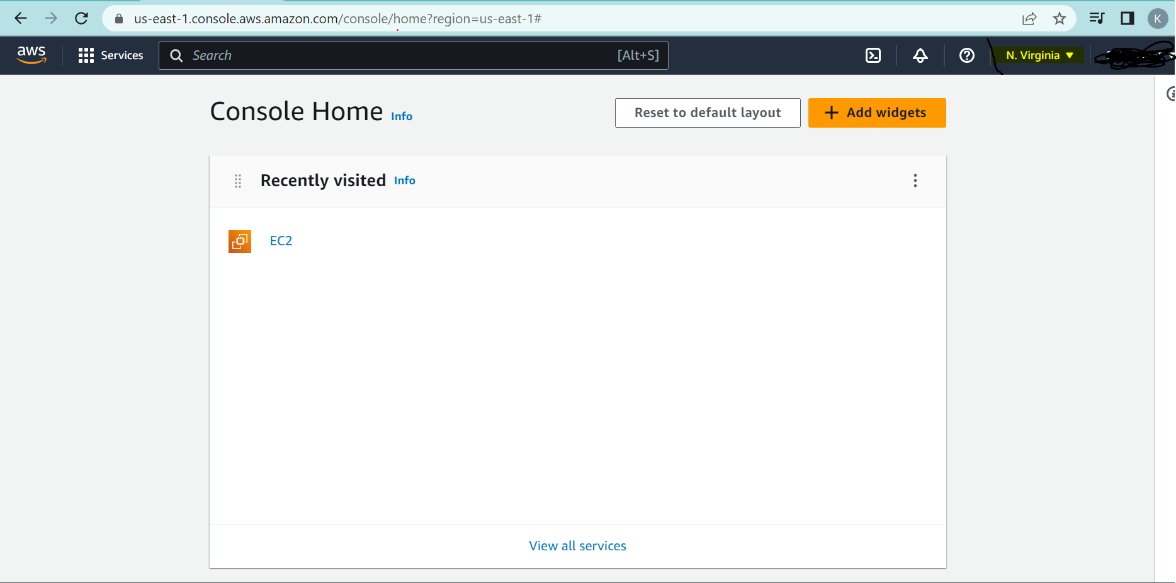

Note :- Please do not select the Govt Regions.

1. Type Ec2 on Search Bar if you are unable to the service and select it.

There you can see the Multiple options once you select the Ec2 Instance like Resources, **Launch instance**, Service health, Zones..etc

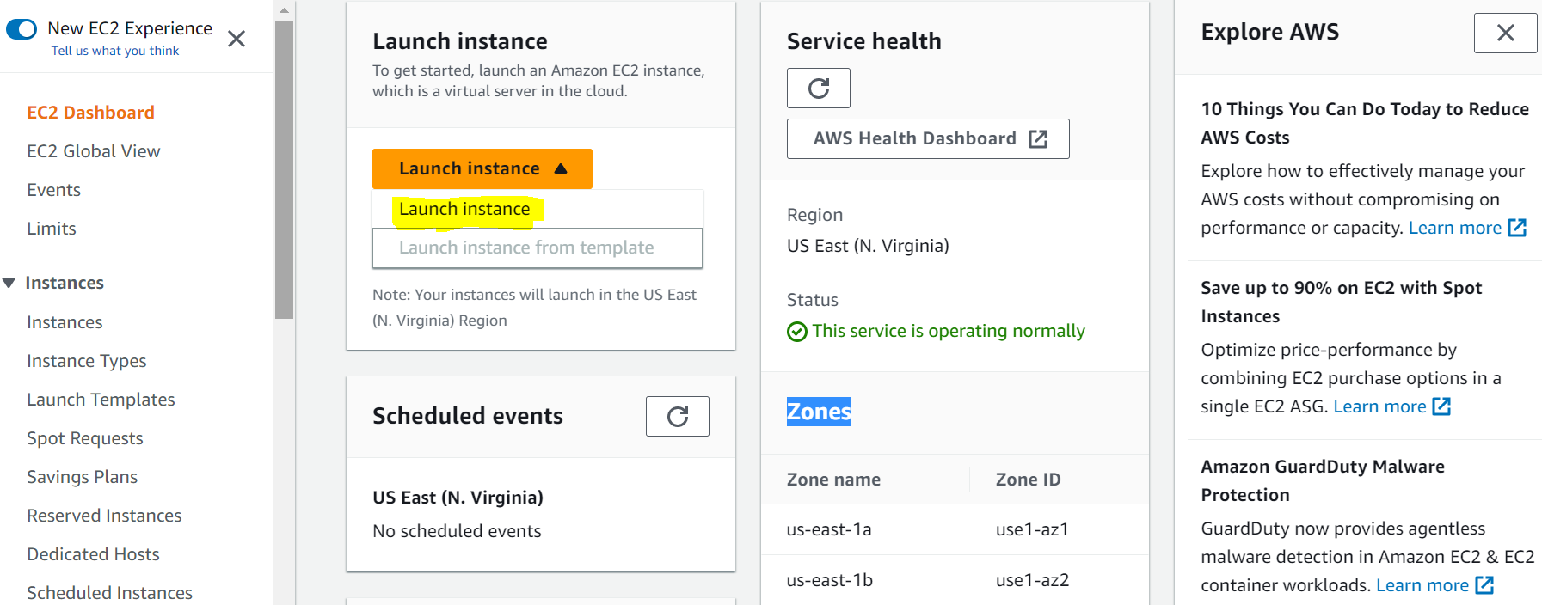

Here select Launch instance and click on Launch

1. Some steps are to be followed to create the Ec2 instance.

1st - Name and tags : [**Any Name**]

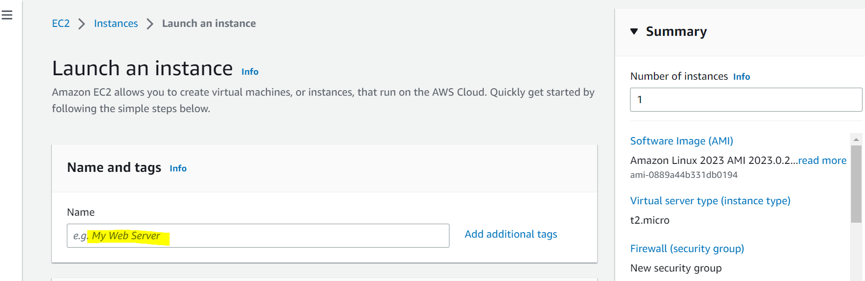

Ex:- MyLinux

2nd :- Application and OS Images (Amazon Machine Image)

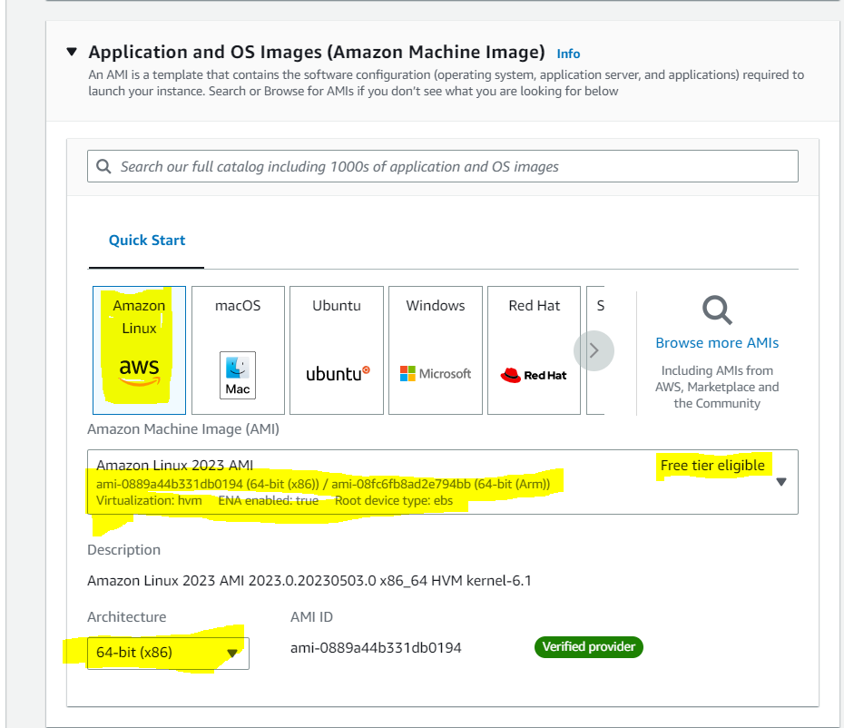

Here choose the AMI, Free tier eligible, Architecture based on you OS

3rd :- Instance type

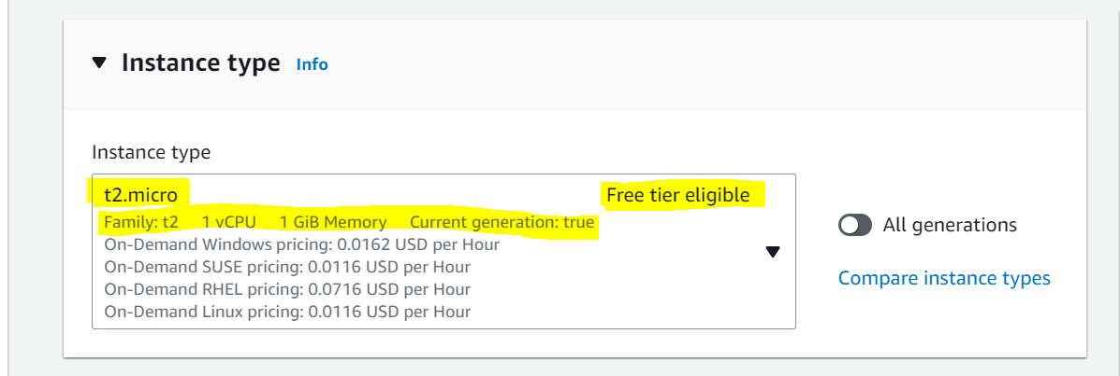

Note:- Here Instance type Must be **t2.micro** and **Free tier eligible.**

4th :- Create Key pair for .Pem file.

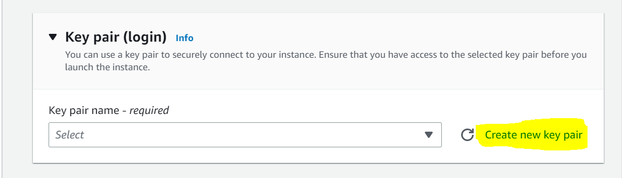

Once you click on create new key pair:-

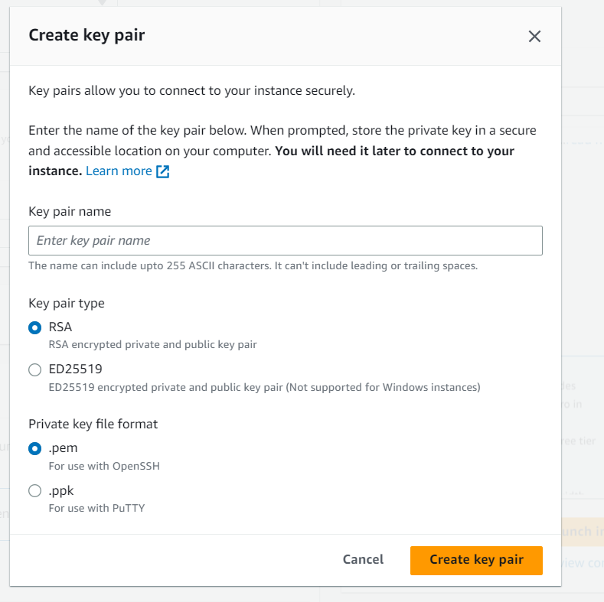

Ex:- Key pair name :- [Any name]

Key pair type :- [Let it be as Default one **RSA** only]

Private key file format:- **.pem**

Note:- You can use existed key pair also instead of create a new key pair. If already exist any key pair.

5th :- Network Settings

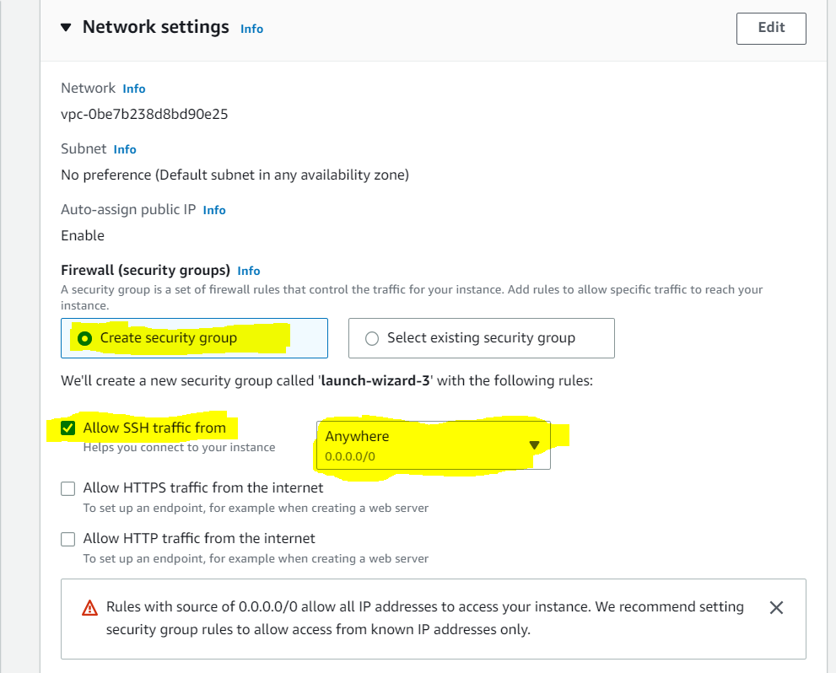

Note:- Here you can select the existing security group instead of create a new one. If already exists any Security group

** Choose the **SSH traffic from [Anywhere 0.0.0.0/0]**

6th :- Configure Storage

** Here Let be same as Default Configure storage

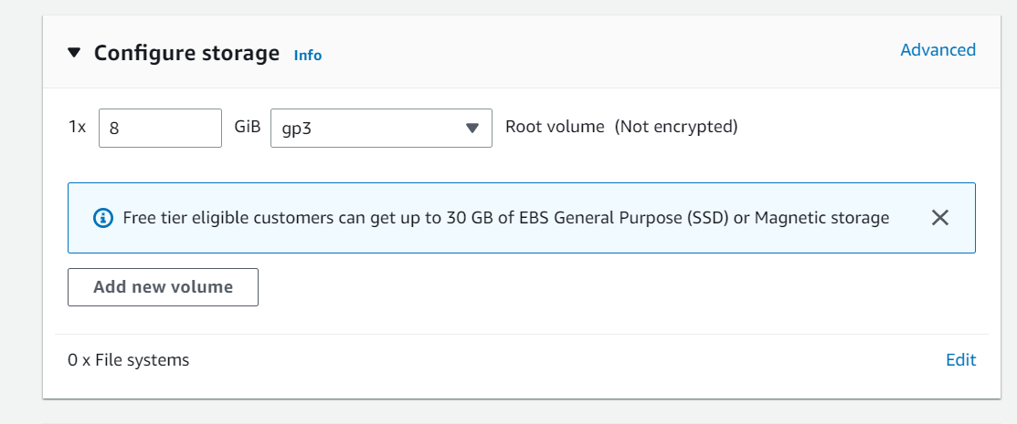

7th :- Don’t touch the Advanced Details [For the Time being].

8th :- Please check the Summary once before you click the **Launch instance.**

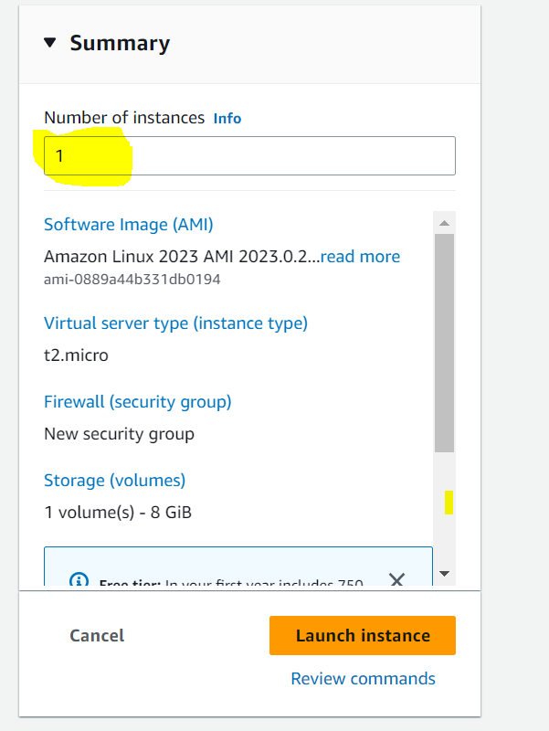

Note:- Number of instances must be only **1[one]**

After Creating the Instance successfully:-

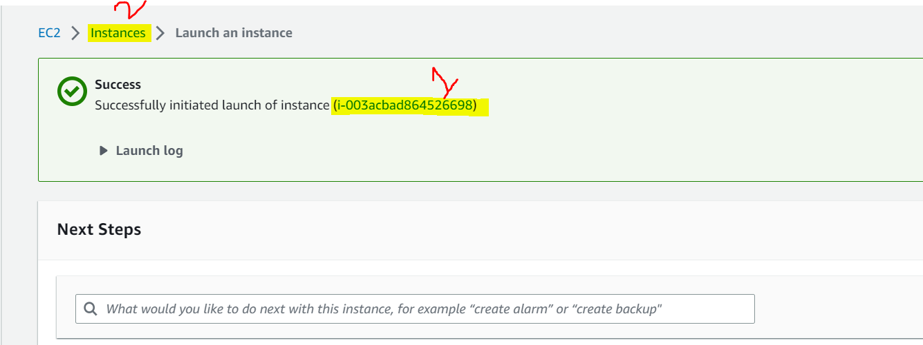

Here click on the **instance-id** (or) **Instances.**

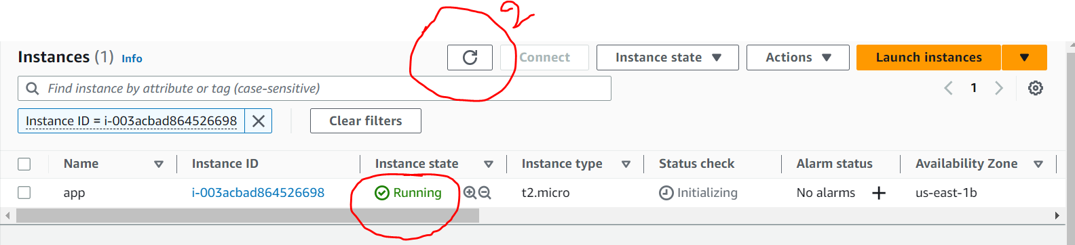

Here, Instance state is **Pending** by default

** Just refresh the refresh option[2] to change the Pending state to Running state.

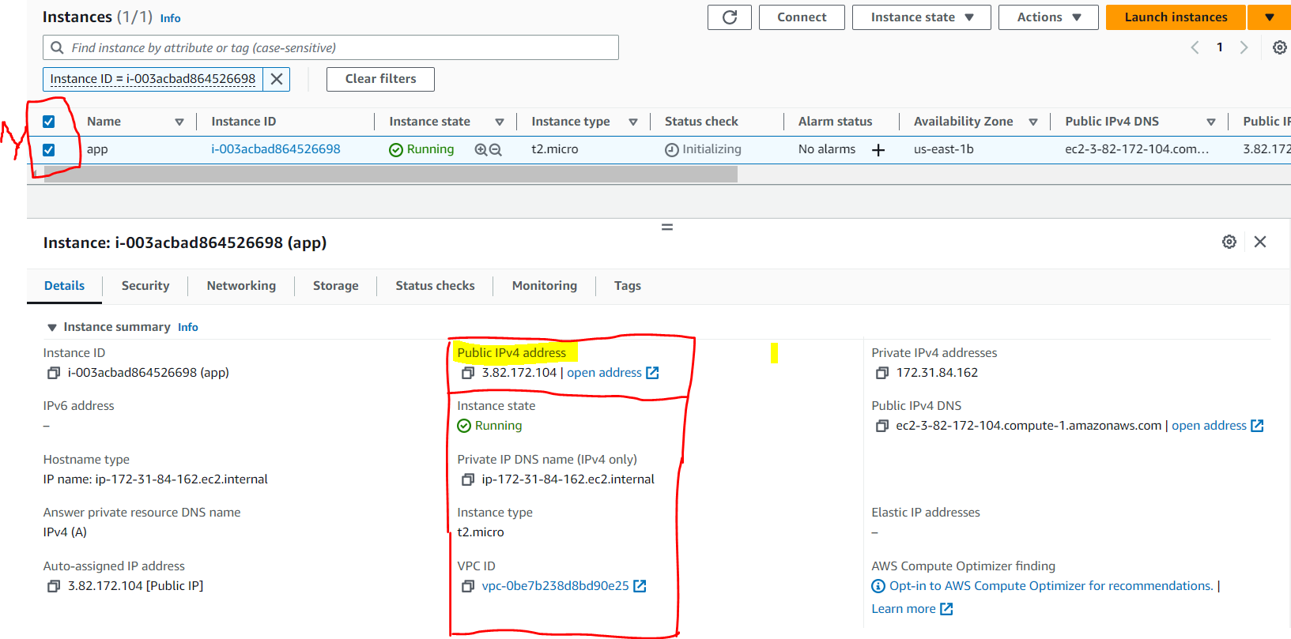

Here, select the check box to copy the **Public IPv4 Address.**

Copy the public IP Address and Go to Mobaxterm (or) WinSCP and Start the Session by using Public IP and Key pair [.pem]

**\*\* IMP Point:-**

Just Terminate the Instance once you done all the Operations.

To Terminate the Instance:-

* Go back to Account

* Select the instace id check box and Select Instance State

Click On Terminate Instance and delete.

